实验1：BGP

<R4>display bgp routing-table

BGP Local router ID is 4.4.4.4

Status codes: \* - valid, > - best, d - damped,

h - history, i - internal, s - suppressed, S - Stale

Origin : i - IGP, e - EGP, ? - incomplete

Total Number of Routes: 3

Network NextHop MED LocPrf PrefVal Path/Ogn

\*>i 1.1.1.1/32 10.0.24.2 0 100 0 100i

\* i 10.0.34.3 0 100 0 100i

\*> 4.4.4.4/32 0.0.0.0 0 0 i

[R3]route-policy lop permit node 10 //设置名为lop的路由策略

Info: New Sequence of this List.

[R3-route-policy]apply local-preference 222 //设置本地优先级为222

[R3-route-policy]quit

[R3]bgp 200

[R3-bgp]peer 10.0.34.4 route-policy lop export //应用策略

[R3-bgp]quit

[R3]quit

<R3>reset bgp all //重启bgp

R4>display bgp routing-table

BGP Local router ID is 4.4.4.4

Status codes: \* - valid, > - best, d - damped,

h - history, i - internal, s - suppressed, S - Stale

Origin : i - IGP, e - EGP, ? - incomplete

Total Number of Routes: 3

Network NextHop MED LocPrf PrefVal Path/Ogn

\*>i 1.1.1.1/32 10.0.34.3 0 222 0 100i

\* i 10.0.24.2 0 100 0 100i

\*> 4.4.4.4/32 0.0.0.0 0 0 i

默认优先级是100

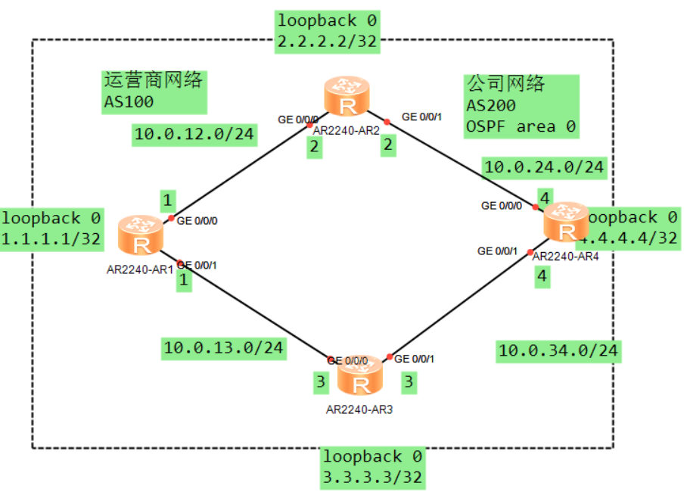

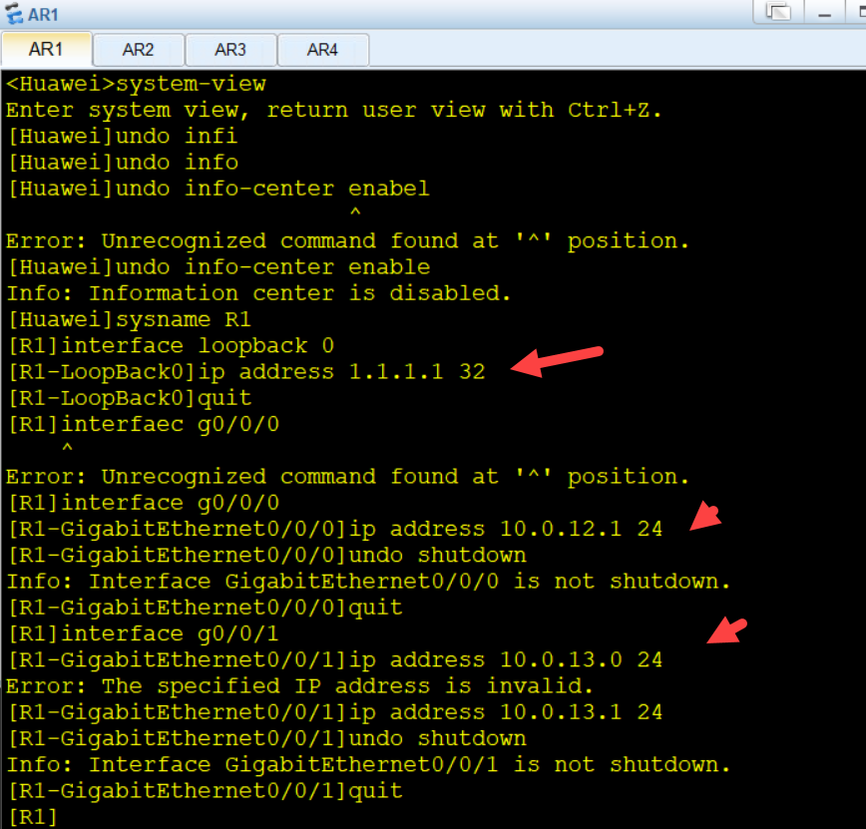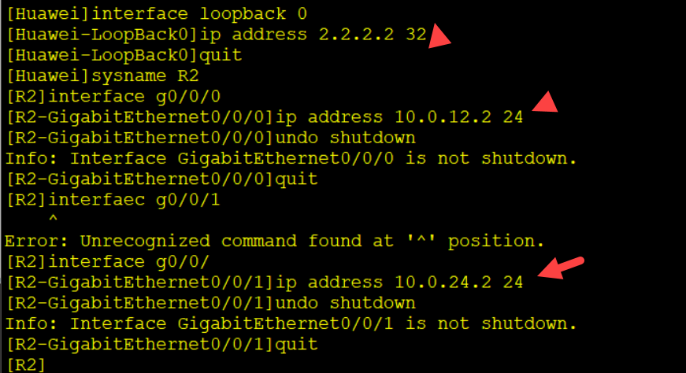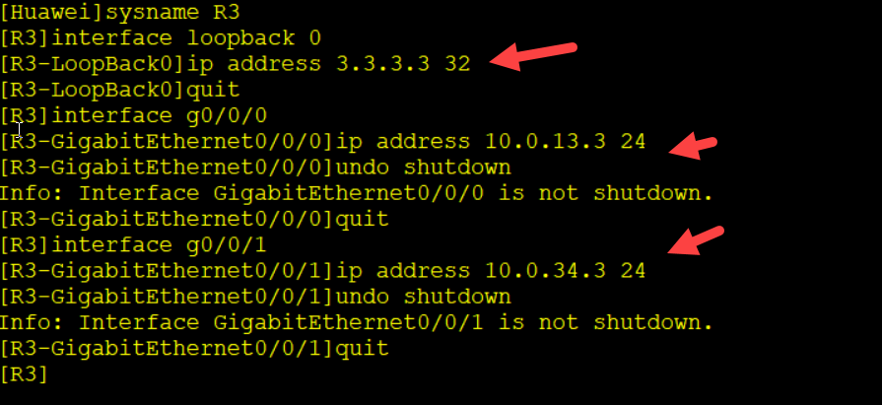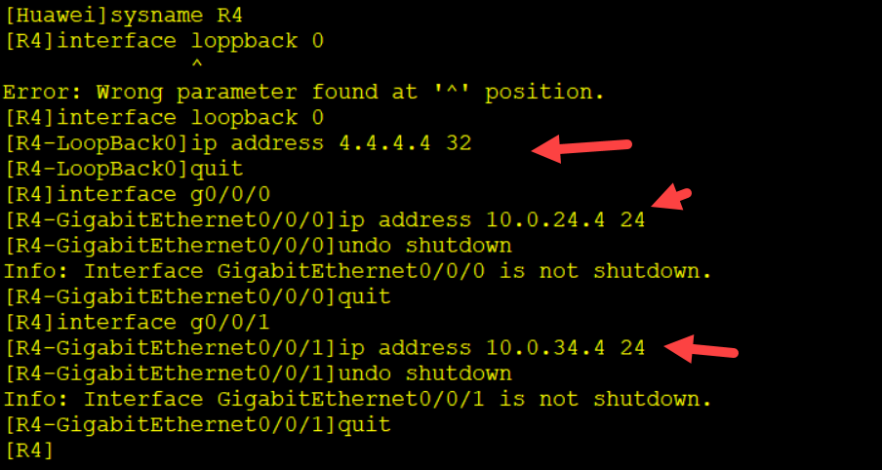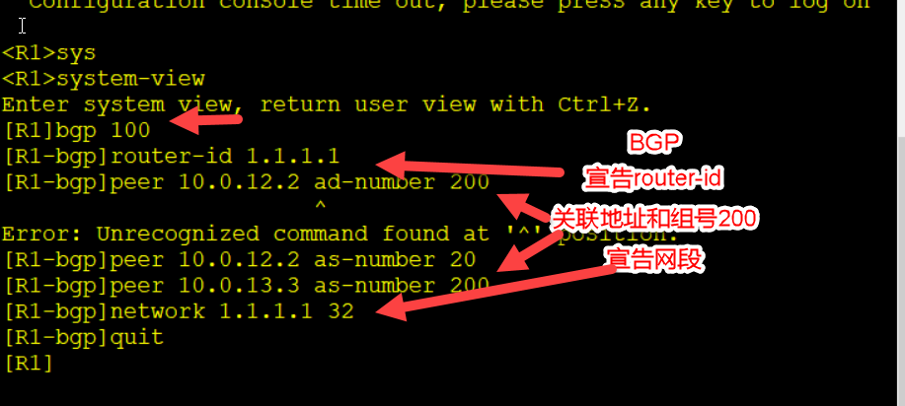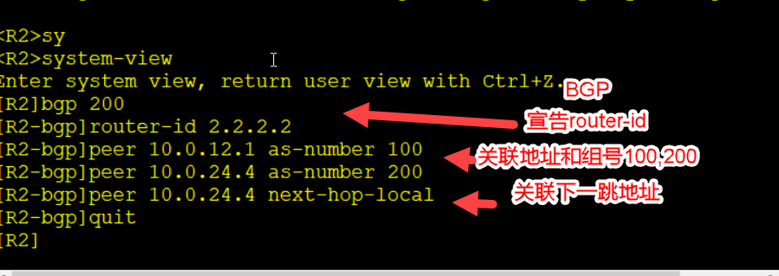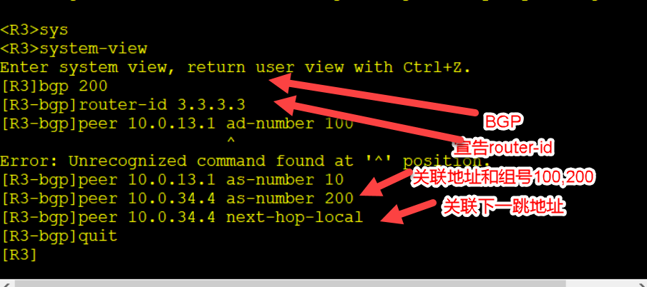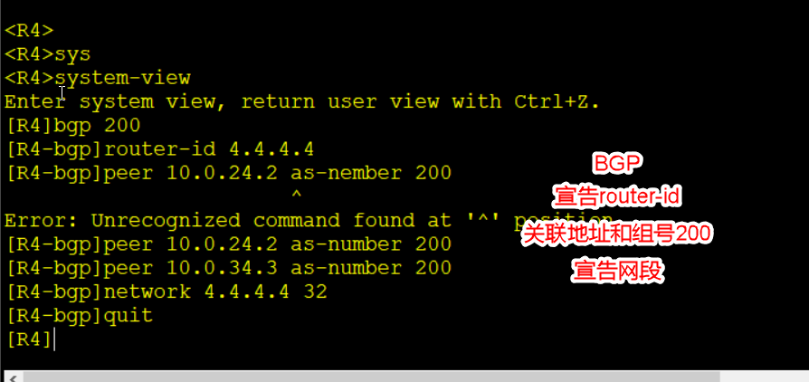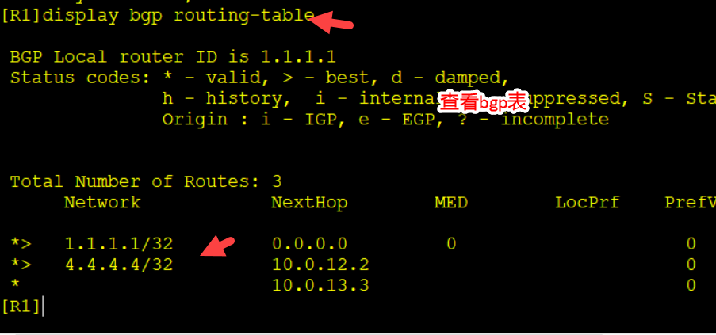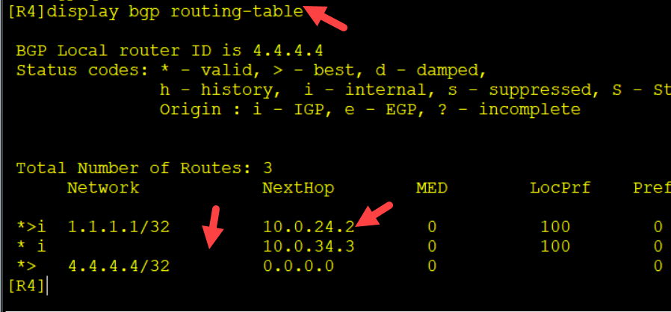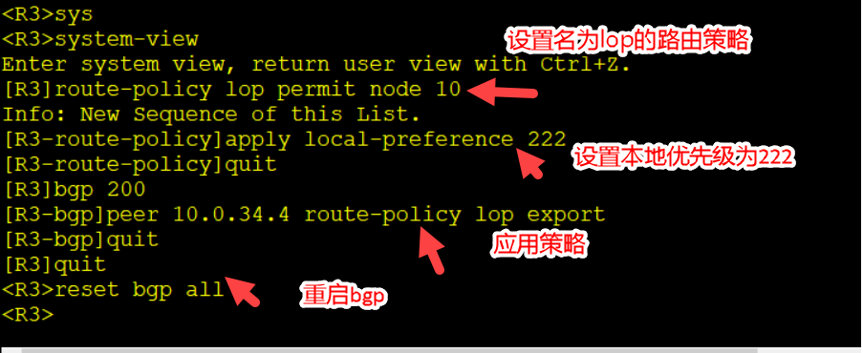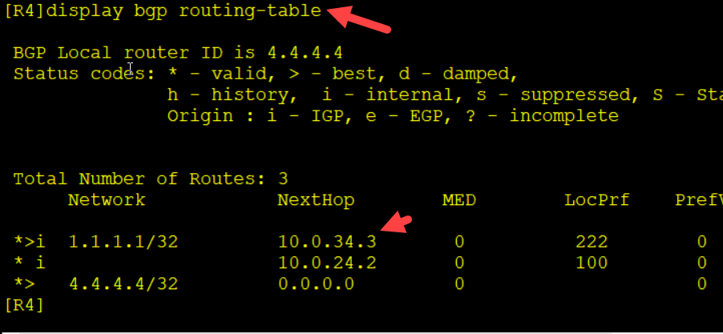

实验2：华为防火墙USG6000初始设置

默认的用户名：admin

默认的密码： Admin@123

[USG6000V1]interface g0/0/0

[USG6000V1-GigabitEthernet0/0/0]service-manage ping permit //此接口允许ping通过

[USG6000V1-GigabitEthernet0/0/0]service-manage enable //服务管理开启

[USG6000V1-GigabitEthernet0/0/0]service-manage https permit //启用https服务

[USG6000V1-GigabitEthernet0/0/0]quit

[USG6000V1]interface g0/0/0

[USG6000V1-GigabitEthernet0/0/0]service-manage all permit 